Practical exercise: Securing the PackSure ML system

PackSure use case overview

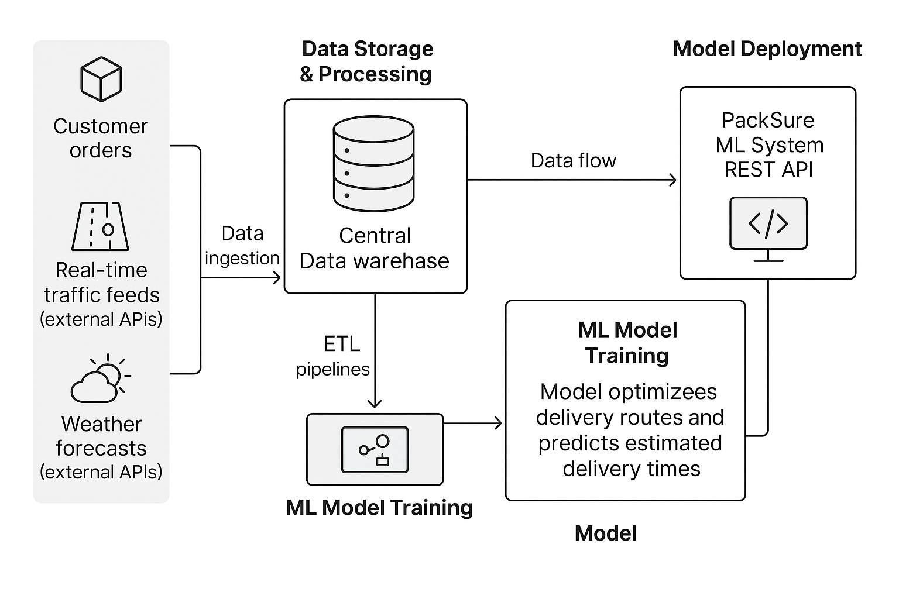
PackSure is a national courier service that uses an ML system to predict optimal delivery routes and estimated delivery times. Their system integrates data from:
- Customer orders (pickup/drop-off details, delivery preferences).
- Real-time traffic feeds (external APIs).
- Weather forecasts (external APIs).
- Historical delivery data.
The PackSure ML model is deployed as a REST API, providing route and delivery time predictions to drivers, customer service teams, and selected third-party logistics partners.
Current security posture:
- API authentication: Basic API key only.
- Data in transit: No encryption enforced.
- Data storage: Central data warehouse for customer data, traffic, and weather inputs.
- Model storage: Trained models stored in a cloud registry, no role-based access control (RBAC).
- Monitoring: No audit logging, limited visibility into API usage patterns.

Your challenge: Secure the PackSure ML system
As the PackSure ML Security Team, your task is to:
- Identify risks:
  - Find at least three vulnerabilities in the PackSure system.
  - Consider risks across data ingestion, storage, model access, and API usage.
- Map to security principles: For each vulnerability, link it to the affected security principle:
- Confidentiality
- Integrity
- Authentication
- Non-repudiation
- Service integrity

- Design mitigations: Propose two mitigation actions for each vulnerability:
  - One technical control (e.g., encryption, API rate limiting).
  - One process control (e.g., access policy, team protocol).
- Draft a secure ML team protocol: Outline how the team will:
  - Monitor for new threats (e.g., anomaly detection, access logs).
  - Respond to security incidents (e.g., escalation steps, rollback procedures).
  - Assign roles and responsibilities for key security tasks.

