System overview: LogiFleet ML system

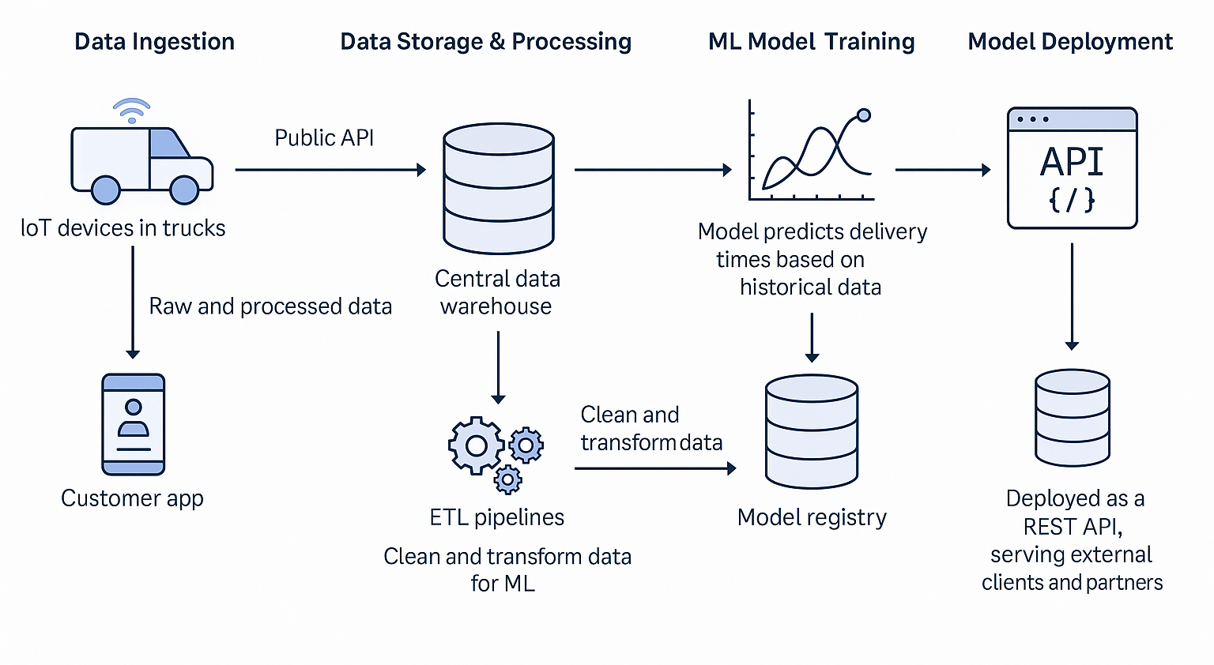LogiFleet uses a machine learning system to predict delivery times for packages. The system consists of the following key components:

Data ingestion
- IoT devices in trucks:
  - Send GPS, speed, and weather data via a public API.
  - Data is transmitted without encryption.
- Customer app: Collects pickup/drop-off details from users.

Data storage & processing
- Central data warehouse: Stores both raw and processed data received from IoT devices and the customer app.
- ETL pipelines: Clean, transform, and prepare data for model training.

ML model training
- Model training: Uses historical delivery data to predict delivery times.
- Model registry: Stores trained models for version control and reuse.

Model deployment
- Inference API:
  - Deployed as a REST API endpoint.
  - Provides delivery time predictions to external clients and partners.
Current security measures:
- API key authentication only (basic).
- No encryption for IoT data streams.
- Minimal rate limiting.
- No audit logging or monitoring.

Discussion Question 1: Where do you see vulnerabilities in this system?
- Data leakage from IoT devices (unsecured GPS, speed, weather data transmitted via public API).
- Model theft via repeated API queries (API key authentication only, no rate limiting).
- API abuse through injection attacks or excessive requests (no input validation, minimal rate limiting).
- Lack of audit logging and monitoring (no visibility into access patterns or anomalies).
- No access control for model registry (risk of unauthorized model updates).
Discussion Question 2: Which security principles are at risk at each stage?

Stage | Vulnerability | Security principle impacted
Data ingestion (IoT devices) | Data leakage | Confidentiality
Model training/storage | Unauthorized access, tampering | Integrity, Non-repudiation
Model deployment / API access | API abuse, model theft | Authentication, Service Integrity, Confidentiality
Monitoring | No visibility, delayed response | Non-repudiation, Service Integrity

Discussion Question 3: What mitigation strategies would you recommend?
- Encrypt IoT data in transit (e.g., TLS/HTTPS).
- Strengthen API authentication (OAuth2, JWT tokens).
- Apply rate limiting and input validation for APIs.
- Implement role-based access control (RBAC) for system components.
- Enable detailed audit logging (who, what, when, where).
- Monitor API usage for anomalies (automated detection tools).

Discussion Prompt: What new risks might emerge if the system expands globally?
- Cross-border data transfer risks (GDPR compliance, data sovereignty laws).
- New regulatory requirements in different countries (e.g., AI Act in the EU).
- Increased exposure of APIs to third-party partners.
- Managing encryption and authentication across distributed environments.

